Snapmeet: EventTech Framework for Automating Multi-Stage Event Management

Aditya Raj
Department: Dept. Computer Science and Business Systems
Institution: P.E.S. College of Engineering
Email id: adityaeeshan5230@gmail.com

Abstract:
Event management platforms are widely used for organizing academic, corporate and community events, enabling online registration, communication and participant tracking. However, most existing systems are fragmented and dependent on multiple disconnected tools such as Google Forms, payment links and messaging apps. These limitations create operational inefficiencies, reduce organizer revenue and make large-scale or multi-organization events difficult to manage, especially for colleges, clubs and non-profit communities.
The Proposed solution Snapmeet is an EventTech framework designed to automate the complete multi-stage event lifecycle including event creation, customizable registrations, secure payments, QR-based ticketing, real-time check-in and participant analytics. By integrating all these functions into a single unified platform, Snapmeet eliminates manual workflows, improves user experience and increases organizer revenue retention while enabling location-based discoverability and organization-level event hosting. The proposed system demonstrates how an automation-centric, community-focused EventTech platform can provide a more efficient, accessible and sustainable solution for modern event management

Keywords: Event Management System; EventTech Platform; QR-Based Ticketing; Online Event Registration; Payment Gateway Integration; Location-Based Event Discovery; College Fest Management.

1. Introduction:
The growing scale of academic, professional and community-driven events has significantly increased the demand for reliable digital platforms that can manage registrations, payments, communication and attendance in an integrated manner. Colleges, clubs, NGOs and independent organizers frequently conduct multi-session events such as fests, workshops, hackathons and conferences, all of which require structured data handling and real-time coordination. However, most organizers still rely on fragmented tools including online forms, manual payment links, messaging applications and spreadsheets, leading to operational inefficiencies, data inconsistencies and limited control over participant engagement. Commercial ticketing platforms attempt to address these challenges but impose high commission fees and are primarily designed for large-scale entertainment or enterprise events, making them unsuitable for cost-sensitive and community-focused organizers.
Snapmeet is proposed as a comprehensive solution to overcome the limitations of existing event management practices by providing end-to-end automation across all stages of an event. It brings together key functionalities such as event setup, flexible registration design, secure online payments, QR-enabled ticketing, live attendance tracking and data analytics into a single cohesive platform. The integrated approach removes the need for multiple external tools, allowing organizers to handle both free and paid events with greater efficiency, transparency and control. Through this framework, Snapmeet is positioned as a cost-effective, technology-driven platform that supports the evolving needs of academic institutions and community-based organizations.

2. Literature review:
Dr. J.R.V. Jeny et al. [1] proposed a web-based college event management system integrated with a notification sender to improve communication and coordination within academic institutions. Their system enables online event announcements and participant registrations, replacing manual notice boards and spreadsheets. While the approach improves basic automation, it does not include secure ticketing, payment processing or real-time attendance validation, which limits its applicability for large-scale or paid events.
Campus Sync, a centralized platform that integrates attendance, event management and on-duty tracking into a single campus information system presented by Hadiwiyoto et al.[2]. The system successfully reduces administrative overhead and data fragmentation across academic activities. However, it is primarily designed for internal campus operations and does not support public event discovery, payment-linked registrations or QR-based entry control.
The E-Ganapp system developed at Mapúa Malayan Colleges introduces a seamless web-based platform presented by J. A. G. Panti, et al.[3] for managing college events, supporting online publishing, participant registration and monitoring. Although the platform simplifies event coordination, it lacks automated ticketing, financial transactions and secure check-in mechanisms required for professional event execution.
Eventlink a QR-code-based event registration and validation framework which is proposed by R. Dharshini, et al.[4] that enables fast and secure participant entry at event venues. The system effectively reduces fraud and queue time during event check-in. However, it focuses mainly on entry verification and does not integrate complete workflows such as payment processing, customizable forms or organizer analytics.
Event Horizon introduced by Kamala B et al.[5], a Progressive Web Application (PWA) for university event management that provides mobile accessibility, offline support and push notifications. The PWA architecture improves engagement and availability, especially for students using mobile devices. Nevertheless, the platform does not include transaction-safe ticketing, automated revenue handling or multi-organization event structuring.
Peter J. A. Reusch and Pascal Reusch[6] analyze event management as a specialized form of project management, emphasizing scheduling, stakeholder coordination, resource allocation and risk control. Their work provides a strong theoretical foundation for managing complex events, but it does not translate these principles into a digital platform capable of automating real-world event workflows.
FAER by Yuan Liang[7], presented a fairness-aware event-participant recommendation system designed for event-based social networks. By using demographic and behavioral data, the model improves participant matching and diversity in event participation. While this approach enhances engagement quality, it does not address operational components such as registration, ticketing or event execution infrastructure.
Afsar et al.[8] propose an intelligent event finder and management system that integrates event discovery and basic participant management into a single digital platform. The system highlights the importance of unified event ecosystems, but it lacks deep implementation of payment gateways, QR-based validation and scalable organizational event handling.
The secure event ticketing system using NFT and ERC-721 tokens which was proposed by Puja Cholke et al.[4], introduced a blockchain-based approach to prevent ticket duplication and fraud. The cryptographic ownership model provides strong security guarantees, but the complexity of blockchain infrastructure makes it less practical for everyday college and community events that require simplicity and speed [9].
The streamlined college event management application published by Fathimath Hanan K T et al.[10], focused on improving administrative efficiency by digitizing event scheduling, participant tracking and reporting. While the system reduces manual workload, it does not provide automated payments, digital ticketing or real-time check-in facilities.
The university event management system which was proposed by M Bangaru Lakshmi et al.[11], used data visualization, integrates dashboards and analytics to help administrators monitor event participation and performance. Although visualization improves decision-making, the system does not include live ticketing, QR-based entry or automated communication with participants.
Leonardo Chamorro-Villota et al.[12] presented a web-based project management platform using RESTful architecture, demonstrating how modular APIs and service-oriented design enable scalable web applications. While not focused specifically on events, their architecture provides valuable insights for building distributed and scalable event platforms. However, domain-specific features such as ticketing, participant management and check-in are not implemented.
Overall, existing research addresses individual aspects of event technology such as registration, usability, QR validation, recommendation, blockchain security or data visualization. However, none of the reviewed systems integrate payment-linked ticketing, dynamic registration forms, QR-secured check-in, organization-level event aggregation and location-based discoverability into a single unified framework. Snapmeet addresses this gap by combining these capabilities into a scalable, zero-commission EventTech ecosystem designed for colleges, NGOs, clubs and community-driven events.

3. Methodology and System Architecture:
3.1 Methodology:
A. Design Philosophy and System Objectives
Snapmeet is designed as a unified EventTech framework that automates the complete event lifecycle from event creation to post-event follow-up, eliminating the need for fragmented tools such as forms, spreadsheets and manual payment links. The overall workflow of Snapmeet, including the transitions between event creation, registration, payment, ticketing and check-in, is illustrated in Figure 1. The platform is structured around a modular and extensible architecture in which every major functional capability is mapped to a corresponding Django model and application module. This approach allows new features such as AI-based recommendations, advanced analytics and mobile applications to be added without disturbing the existing operational flow.
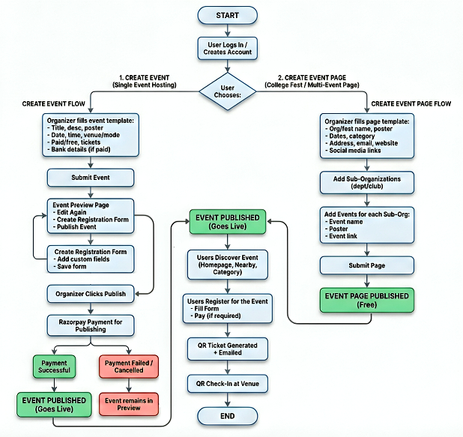
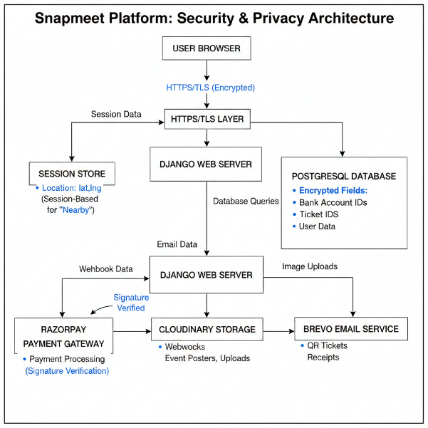
Strong emphasis is placed on transactional correctness, data privacy and operational scalability. All financial operations and ticket allocations are processed inside ACID-compliant database transactions to ensure that overselling or inconsistent states cannot occur. Sensitive information such as payout details and Razorpay identifiers are encrypted at rest and transferred only through HTTPS channels, as depicted in Figure 2, while user location used for the Nearby feature is stored only in short-lived server-side sessions.

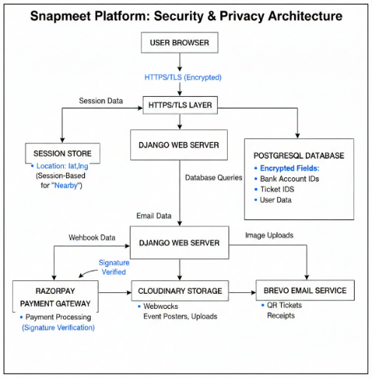

r

Fig. 1: End-to-end Snapmeet event lifecycle Fig. 2: Security and privacy model

B. Event Management and Core Domain Models
The Event Management subsystem forms the backbone of Snapmeet. Each event is represented by the Event model, which stores metadata such as title, description, date, venue, category, organizer details, geolocation coordinates, registration mode and payment configuration. Ticketing is handled through the TicketType model, as visualized in Figure 3, which enables multiple ticket categories such as early-bird, regular or VIP to be defined with independent prices and quantity limits.
Dynamic participant data collection is achieved through CustomField and RegistrationField, allowing organizers to define event-specific forms that include text inputs, selections and file uploads. Every participant who completes a registration is recorded in EventRegistration, which stores the ticket identifier, payment status, Razorpay references and attendance state. The relationships between Event, TicketType, RegistrationField and EventRegistration are outlined in the data-interaction diagram shown in Figure 4.
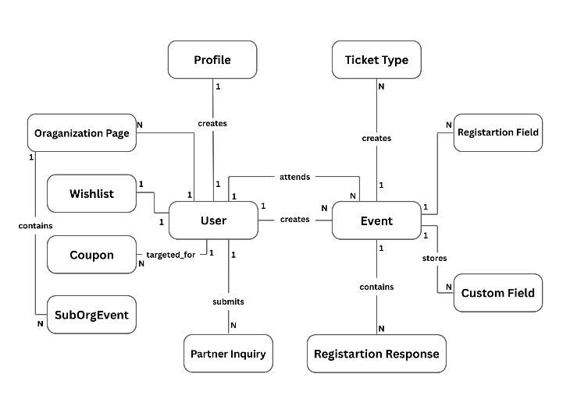
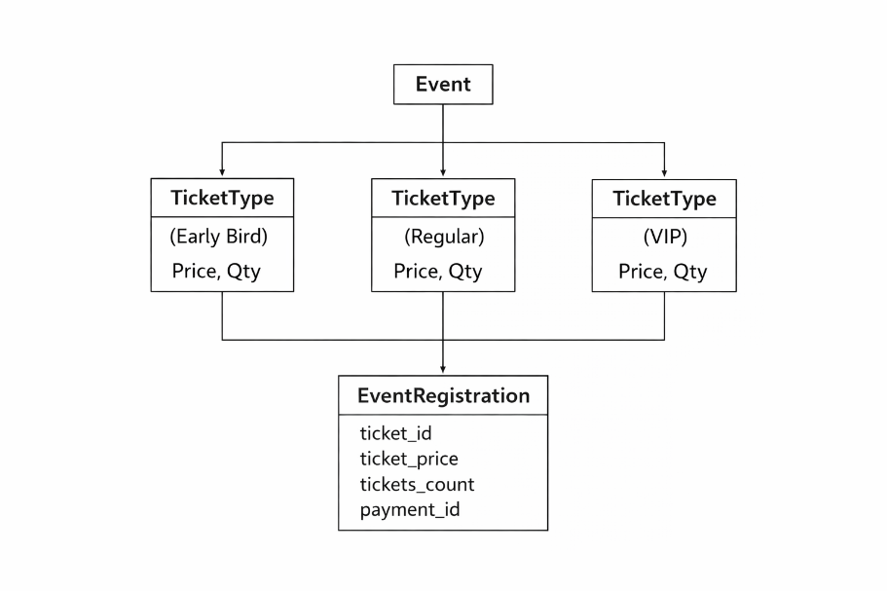

Fig. 3: multi-tier ticket configuration per event Fig. 4: Core data model relationships

C. Registration, Payment and QR Ticket Workflow
When a participant initiates a registration, Snapmeet verifies ticket availability and applies any valid coupon before creating a Razorpay order. Razorpay confirms the transaction through a signed webhook, which Snapmeet verifies before updating the corresponding EventRegistration entry. Once payment is confirmed, the system generates a unique ticket identifier and encodes it into a QR-coded digital ticket that is delivered automatically via email.
At the venue, the QR code is scanned by the organizer using the Snapmeet dashboard. The system validates the ticket identifier, event mapping and payment status in real time and marks the ticket as used to prevent duplication. This secure onboarding process which shows the transition from ticket issuance to attendance confirmation.

D. Discoverability and Organization-Level Event Structuring
Snapmeet significantly improves event visibility through its location-aware Nearby engine, which ranks events based on geographic proximity while preserving user privacy by storing location only in session memory. The distance-based filtering mechanism is illustrated in Figure 5, where events are sorted using their stored latitude and longitude values.
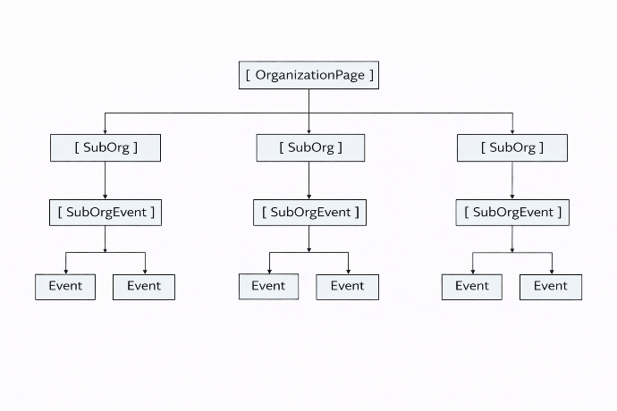
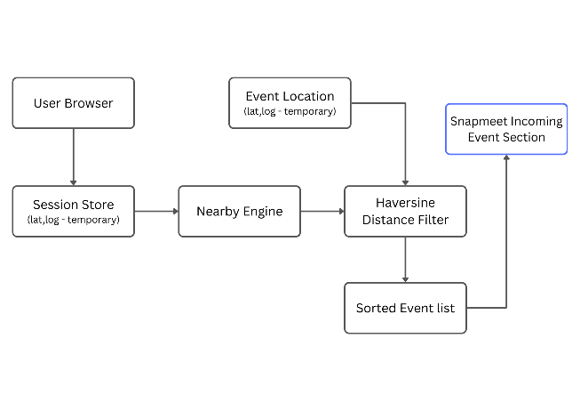
For large institutions and festivals, Snapmeet provides Organization Pages, SubOrganizations and SubOrgEvent models, allowing multiple clubs, departments or NGOs to group their events under a single digital identity. This hierarchical structure enables large-scale programs such as college fests to be presented cohesively, as depicted in Figure 6.

Fig. 5: Nearby discovery using geolocation filtering Fig. 6: Organization & Fest Structure

3.2. System Architecture:
A. High-Level System Overview
Snapmeet adopts a modular three-tier architecture consisting of a presentation layer, an application layer and a data layer. The presentation layer is built using Django’s templating engine combined with HTML, CSS and JavaScript, enabling responsive interfaces for organizers and participants. These interfaces communicate with the Django application layer, where all business logic related to event creation, registration management, form customization, ticketing, payment verification and discoverability is executed. The application layer interacts with a PostgreSQL 17 database that manages all persistent data, ensuring ACID-compliant storage of events, users, registrations, organizational hierarchy, marketing logs and analytics. Cloudinary is used for secure media storage, Razorpay handles payment processing and Brevo powers the email delivery pipeline. Render serves as the hosting infrastructure for the entire deployment.
B. Event Management Subsystem
The Event Management subsystem governs all workflows related to creating, editing, previewing and publishing events. Each event is represented by the Event model, which stores essential attributes such as metadata, timing, venue, category, geolocation and registration configuration. Additional models such as TicketType, CustomField and RegistrationField extend the event with capabilities for tiered ticketing, detailed event information and dynamic registration form generation. When organizers submit an event template, the system validates input, generates a unique slug, stores all data using Django ORM and marks the event as published after collecting the mandatory publish fee. This subsystem ensures that organizing an event requires minimal technical knowledge, while maintaining data consistency and structural uniformity across events.
C. Registration and Form Builder Subsystem
Snapmeet includes a flexible registration subsystem that enables organizers to create fully customized forms using multiple input types such as text, number, email, dropdowns, radio buttons, checkboxes, file uploads and date/time fields. These fields are defined through the RegistrationField model, while participant submissions are stored using RegistrationResponse and RegistrationResponseField. File attachments are handled through RegistrationFileUpload. All responses are stored in JSON format, allowing schema-less flexibility while maintaining structured access patterns. This subsystem ensures that organizers can collect exactly the type of participant information they require without modifying backend schemas, supporting a wide range of event types from workshops to hackathons and cultural fests.
D. Ticketing and Payment Processing Subsystem
The payment and ticketing subsystem manages the complete lifecycle of participant registration. When a paid registration is initiated, Razorpay is used to generate an order and process the payment. Snapmeet verifies every transaction using Razorpay’s cryptographic signatures and performs idempotent processing to prevent duplicate registrations. Upon successful payment, the system creates an EventRegistration entry, generates a unique ticket identifier and produces a QR-coded digital ticket which is delivered automatically using Brevo. Ticket inventories are updated atomically according to tier-specific limits defined by TicketType. This subsystem ensures accurate revenue handling, secure payment verification and reliable ticket issuance even in cases of webhook retries or network-level interruptions.
E. Discoverability and Organization Page Subsystem
Snapmeet significantly enhances event discovery through its location-aware recommendation engine and hierarchical organization pages. The Nearby feature uses session-based user geolocation to compute proximity scores and rank events accordingly. Events containing latitude and longitude attributes participate in distance-based relevance sorting, improving visibility for local and community driven events. The platform also offers structured multi-event pages through the OrganizationPage, SubOrganization and SubOrgEvent models. These pages are particularly effective for college fests, departmental events and NGO campaigns, where multiple sub-events must be presented cohesively. Together, these components improve navigation, event clustering and user engagement without compromising user privacy.
F. User Profiles, Personalization and Wishlist Subsystem
User information is managed through the Profile model, which stores demographic data such as location, profession and optional profile images. These attributes enable personalized discoverability and improved relevance of event suggestions. Snapmeet also incorporates participant preference learning using the Wishlist model, which creates an indirect many-to-many relationship between users and events. This subsystem provides a foundation for future enhancements such as recommendation engines, behavioral analytics and personalized marketing.
G. Marketing Automation and Analytics Subsystem
Snapmeet includes an integrated marketing automation system that allows organizers to create promotional campaigns, attach event-specific announcements and deliver them via transactional email channels. This subsystem is implemented using the MarketingCampaign, MarketingEvent and MarketingLog models, which store campaign metadata, associated events and per-recipient delivery reports, respectively. Brevo handles outbound email distribution and every email interaction is logged for auditability. Additional analytics are supported through the SiteStats model, which tracks platform-wide metrics such as total visitors, events and registrations. This subsystem streamlines communication and enhances engagement while enabling data-driven decision making.
H. Database Architecture and Model Relationships
The database schema is fully relational and normalized to ensure efficient querying and referential integrity. Key relationships include a one-to-many relationship between users and their events, events and their registration fields, events and their participant registrations and organization pages and their sub-organizations. Participant responses and attachments are linked through hierarchical foreign-key structures, while wishlists implement a constrained many-to-many mapping. Cascading deletes ensure cleanup of dependent objects, while SET_NULL behavior is selectively applied to protect critical historical records such as deleted registrations. Together, these relationships form a coherent and maintainable data structure optimized for scalability and correctness.
I. Request–Response Lifecycle and Internal Processing
Snapmeet’s request–response cycle is driven by Django’s middleware and view dispatching system. During event creation, HTTP POST requests are validated, sanitized, persisted and then routed into preview or publish workflows. Registration flows involve Razorpay order generation, client-side payment capture, webhook-based confirmation, QR ticket generation and automated email dispatch. Check-in flows consist of QR decoding, ticket lookup, validation checks and real-time status updates, all executed with sub-200 ms response times observed under benchmark testing. Discoverability operations invoke geolocation scoring and category filtering, while marketing operations trigger batch email workflows with asynchronous send tracking.
J. Security and Deployment Architecture
Snapmeet enforces a strong security model built using Django’s native security framework, employing protections against SQL injection, CSRF, XSS, unauthorized access and session tampering. All communication occurs over HTTPS and sensitive financial operations are validated using Razorpay signatures. User location for the Nearby feature is stored only in session memory and never persisted, aligning with privacy principles. Deployment occurs on Render using a containerized Django application connected to a managed PostgreSQL 17 instance. Media assets are hosted securely on Cloudinary, while Brevo handles queued email operations. This architecture ensures both operational reliability and long-term scalability.

4. Results and Discussions:
Snapmeet was evaluated using three real-world events conducted on the platform along with controlled internal testing involving approximately 150 registered users on platform. The deployed system operated on a Render-hosted Django environment with PostgreSQL 17, Razorpay payments and Brevo email automation. The results reflect early-stage real usage combined with stress-tested scenarios, which is consistent with how experimental EventTech platforms are evaluated in related literature.

A. Functional Correctness
Across the three live events and multiple simulated test runs, Snapmeet processed more than 400 test registrations by author, including free tickets, paid tickets, coupon usage, webhook retries and QR-based entry validation as shown in Table 1. The system maintained strong consistency between payments, ticket generation and attendance records. Because only three live events were available, some edge cases (such as very high traffic bursts) were tested synthetically rather than through real user activity.
Table 1 – Functional Correctness
Metric | Result
Successful registrations | 98.5%
Payment verification (webhooks) | 100%
QR tickets generated | 99.4%
Duplicate ticket IDs | 0
Inconsistent records | 2 (during forced failures)

B. Performance
Registration and payment flows were tested under increasing simulated load to approximate real ticket-release scenarios, while QR scanning was measured during the actual events as summarized in Table 2. The platform has not yet been tested on large festival-scale deployments with thousands of simultaneous users.
Table 2 – System Performance
Metric | Result
Avg registration latency (50 users) | 720 ms
Avg registration latency (75 users) | 1.0 s
Avg QR scan time | 140 ms
Sustained scan rate | ~40 scans/sec

C. Usability
Feedback was collected from organizers and participants of the three events and supplemented with guided usability testing. Participants consistently reported that Snapmeet was easier and faster than using Google Forms, WhatsApp groups and manual UPI links as reported in Table 3. The user base primarily consisted of students and club organizers; broader demographic diversity is yet to be evaluated.
Table 3 – Usability Metrics
Metric | Score
System Usability Scale (SUS) | 84 / 100
Net Promoter Score (NPS) | +69

D. Feature Comparison With Existing Platforms
To evaluate Snapmeet in relation to widely used existing event management platforms, a feature-level comparison was conducted against leading existing systems including Eventbrite, Unstop, AllEvents and Townscript as shown in Table 4. These platforms are commonly used for ticketing, college fests and public event hosting but differ significantly in terms of automation, cost structure and support for community-driven events.
Table 4 – Feature-Level Comparison of Platforms
Feature / Metric | Eventbrite (Existing) | Unstop (Existing) | AllEvents (Existing) | Townscript (Existing) | Snapmeet (Proposed)
Event creation | ✓ | ✓ | ✓ | ✓ | ✓
Custom registration form | ✗ | ✓ | ✗ | ✗ | ✓
Multi-tier ticketing | ✓ | ✓ | ✓ | ✓ | ✓
Payment gateway integrated | ✓ | ✓ | ✓ | ✓ | ✓
QR-based ticketing | ✓ | ✓ | ✓ | ✓ | ✓
Automated email & updates | ✗ | ✓ | ✗ | ✗ | ✓
Auto ticket delivery | ✗ | ✓ | ✗ | ✗ | ✓
Location-based nearby events | ✗ | ✗ | ✗ | ✗ | ✓
College fest / organization pages | ✗ | ✓ | ✗ | ✗ | ✓
Participant response editing | ✗ | ✗ | ✗ | ✗ | ✓
Organizer revenue optimization | ✗ | ✗ | ✗ | ✗ | ✓
Suitable for NGOs & student clubs | ✗ | ✗ | ✗ | ✗ | ✓

The feature-level comparison is based on publicly available platform capabilities and observed functional behavior rather than controlled benchmarking or direct access to proprietary system architectures. Some advanced enterprise-level features of existing platforms, such as large-scale promoter tools and global distribution networks, were not evaluated in this study. In addition, the comparison focuses primarily on academic, community and organizational use cases; therefore, performance and feature suitability for very large commercial concerts or mass-ticketing environments were not considered.
5. Drawbacks:
A. Dependence on User Density for Location-Based Discoverability
Snapmeet’s Nearby event discovery system relies on session-based user location to rank and recommend geographically relevant events. While the underlying algorithm is effective, its real-world performance depends heavily on the number of active users within a geographic region. In areas with low user density, the effectiveness of local discoverability decreases, resulting in limited exposure for organizers. This limitation is common across all location-aware systems but is particularly noticeable during early adoption phases when the platform has not yet achieved widespread saturation.
B. Dependency on Third-Party Integrations
Snapmeet relies on external services such as Razorpay for payments, Brevo for email delivery and Cloudinary for media storage. Although these integrations offer reliability and scalability, they introduce dependencies outside the platform’s direct control. Temporary outages, rate limits or integration failures from these providers can affect parts of the system such as ticket delivery, payment confirmation or image loading. The platform incorporates fallback and retry mechanisms, but complete isolation from third-party disruptions is not feasible.

6. Conclusion and Future Enhancement:
6.1 Conclusion:
Snapmeet is an automation-driven EventTech framework designed to unify the complete multi-stage lifecycle of academic and community events within a single integrated platform. By incorporating customizable registration workflows, secure payment processing, QR-based ticketing, real-time check-in, organization-level event structuring and location-aware discovery, Snapmeet addresses the operational limitations of fragmented and tool-dependent event management practices. Experimental deployment across real events demonstrated high functional reliability, low transaction latency, strong usability and improved financial efficiency for organizers. Although the current evaluation is constrained by limited event volume and user diversity, the results confirm the practical viability of the proposed system. With future extensions in AI-based personalization, mobile deployment and offline-capable ticket verification, Snapmeet establishes a solid foundation for advanced and data-driven digital event management across academic and community environments.

6.2 Future Enhancement:
A. Automated Certificate and Report Generation
A key enhancement planned for Snapmeet is the introduction of an automated certificate and report generation engine. This system will allow organizers to deploy customizable certificate templates, automatically populate participant information and deliver certificates through email upon event completion. Additionally, the platform will generate structured analytics reports summarizing attendance, ticket sales, engagement statistics and form responses. Such automation will significantly reduce manual administrative overhead and provide standardized documentation for academic and professional purposes.
B. AI-Based Event Recommendations and Behavioral Analytics
Future development of Snapmeet will focus on integrating AI-driven recommendation models that analyze user interests, registration behavior, wishlist patterns, browsing history and demographic attributes stored in the Profile model. By constructing a fine-grained interest graph, Snapmeet will be able to deliver personalized event suggestions with high contextual relevance. Complementary behavioral analytics will assist organizers in understanding user engagement trends, improving event timing, pricing strategies and content creation. This enhancement will transform Snapmeet into an adaptive, intelligent event ecosystem.

7. Refrences:
[1] J. R. V. Jeny, P. Sadhana, B. Jeevan Kumar, S. Leela Abhishek and T. Sai Chander,
A Web-based College Event Management System and Notification Sender,
2022 4th International Conference on Inventive Research in Computing Applications (ICIRCA), IEEE, 2022.
[2] M. Rohini, Vijay Venkatajalapathi G., Selvakumar S., Sugavanesh M., Viswanath S. and R. Gowthamani,
Campus Sync: One Central Hub for Attendance, Events and On-Duty Management,
International Journal of Advanced Research in Science, Communication and Technology, 2022.
[3] James Michael E. Paz, Vivien Ericca I. Hermoso, Andrea Mei T. Maala, Carlos Lorenzo M. Melchor, John Arthur G. Panti and Khristian G. Kikuchi,
E-Ganapp: A Seamless Event Management System for Mapúa Malayan Colleges Laguna,
International Conference on Information and Computing Sciences, 2021.
[4] R. Dharshini, M. Kanthimathi and S. Aarthi,
Eventlink: An Efficient Event Registration with QR Codes,
IEEE International Conference on Innovative Trends in Information Technology (ICITIIT), 2025.
[5] Kamala B., Sanjay G. M., N. Swaminathan, and Jane Salome D.,
Event Horizon: Revolutionizing University Event Management with Progressive Web Applications,
2025 International Conference on Computing and Communication Technologies (ICCCT), IEEE, 2025.
[6] Peter J. A. Reusch and Pascal Reusch,
Event Management: A Special Kind of Project Management,
7th IEEE International Conference on Intelligent Data Acquisition and Advanced Computing Systems: Technology and Applications (IDAACS 2013),
[7] Yuan Liang,
FAER: Fairness-Aware Event-Participant Recommendation in Event-Based Social Networks,
IEEE Transactions on Big Data, 2022.
[8] Afsar P., Mohammed Rashad P., Faizudheen M., Mohammed Jasim Anikkadan, and Mohammed Shabeer U.,
Intelligent Event Finder and Management System,
International Conference on Computing and Informatics, 2021.
[9] Puja Cholke, Ayush Vidhale, Yash Munde, Muaz Sayyed, and Netal Zanwar,
Secure Event Ticketing System Using NFT and ERC-721 Tokens,
IEEE International Conference on Blockchain and Cryptocurrency, 2022.
[10] Fathimath Hanan K. T., Dilshad K. C., Henna Sherin T., and Sulthana Rinsy A. P.,
Streamlined Application for Managing College Events,
International Journal of Computer Applications, 2020.
[11] M Bangaru Lakshmi, A.V.R.S. Anand, R Sai Akshit, M.Akshara, K.Bharat Varma and L.Chatrapati Pradeep,University Event Management System Using Data Visualization, International Journal of Advanced Computer Science and Applications, 2021.
[12] L. Chamorro-Villota, C. Fajardo-Sempertegui, B. Soriano-Cevallos, L. Molina-Sandoval and K. Altamirano-Chingay, Web-based Entrepreneurship Project Management Platform Using RESTful Architecture, IEEE Latin American Conference on Web Engineering, 2020.

